MIS 6326.501 – Data Management - Assignment 4
Swetha Krishnakumar (sxk151530)

Assignment 1 SQL Fundamentals

Total points: 50

This assignment should be completed individually. For each problem, submit your SQL statement and a screen shot of the SQL results in a single Word document or pdf file. Submit the file via eLearning.

I recommend creating a new user and workspace, log in as that user and load the database script ourvideo.sql (provided in this week's assignment folder).
Before you attempt to write any SQL queries, familiarize yourself with the database structure and data. I have provided a relational diagram and sample data for this database.
Write queries to address each of the problems below. Submit both the SQL statements and the screen prints of the outputs from Oracle.
OurVideo is a small movie rental company with a single store. OurVideo needs a database system to track the rental of movies to its members. OurVideo can own several copies (VIDEO) of each movie (MOVIE). For example, the store may have 10 copies of the movie “Twist in the Wind”. “Twist in the Wind” would be one MOVIE and each copy would be a VIDEO. A rental transaction (RENTAL) involves one or more videos being rented to a member (MEMBERSHIP). A video can be rented many times over its lifetime, therefore, there is a M:N relationship between RENTAL and VIDEO. DETAILRENTAL is the bridge table to resolve this relationship. The complete ERD is provided in the Figure below.
OurVideo ERD
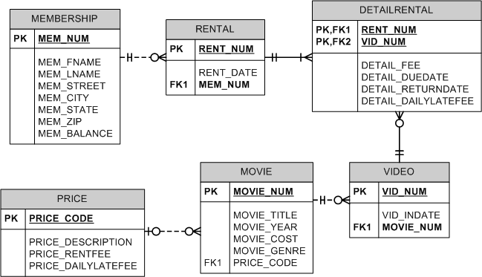

1.A. Explain the correct sequence in which the tables should be created and why it should be in that order. (NOTE: this is based on referential integrity constraints). (2pts)

Solution:
The order in which the tables should be created is as follows:
- Membership
- Rental
- Price
- Movie
- Video
- DetailRental

Since Rental has a foreign key that is referenced to Membership table, to avoid referential integrity problem, Membership should be created before Rental table. Similarly, Movie has a foreign key that is referenced to Video table, Price has a foreign key that is referenced to Video table, DetailRental has 2 foreign keys. So, Price, Movie, Video, DetailRental should be created in that order.

1.B. Write the SQL code to create the table structures for the RENTAL AND DETAILRENTAL entities shown in the Figure. The structures should contain the attributes specified in the ERD. Use data types that would be appropriate for the data that will need to be stored in each attribute. Enforce primary key and foreign key constraints as indicated by the ERD. (4 pts)

Solution:

RENTAL:

CREATE TABLE RENTAL (
RENT_NUM NUMBER(8,2)
CONSTRAINT RENTAL_RENT_NUM_PK PRIMARY KEY,
RENT_DATE VARCHAR2(20) NOT NULL,
MEM_NUM NUMBER,
CONSTRAINT RENTAL_MEM_NUM_FK
FOREIGN KEY (MEM_NUM) REFERENCES MEMBERSHIP);

DETAILRENTAL:

CREATE TABLE DETAILRENTAL (
RENT_NUM NUMBER(8,2) NOT NULL,
VID_NUM NUMBER(8,2) NOT NULL,
DETAIL_FEE DECIMAL(8,2) DEFAULT 0.00 NOT NULL,
DETAIL_DUEDATE VARCHAR2(20) NOT NULL,
DETAIL_RETURNDATE VARCHAR2(20) NULL,
DETAIL_DAILYLATEFEE DECIMAL(8,2) DEFAULT 0.00 NOT NULL,
PRIMARY KEY (RENT_NUM,VID_NUM),
CONSTRAINT DETAILRENTAL_RENT_NUM_FK
FOREIGN KEY (RENT_NUM) REFERENCES RENTAL,
CONSTRAINT DETAILRENTAL_VID_NUM_FK
FOREIGN KEY (VID_NUM) REFERENCES VIDEO);

2.A. Based on the referential integrity constraints, identify the correct sequence in which to insert data
into the tables (list the order). (2 pts)

Solution:
The order in which data should be inserted into the tables is as follows:
- Membership
- Rental
- Price
- Movie
- Video
- DetailRental

2.B. Write the INSERT commands necessary to place the following data in the tables that were created in problem 1.B. (5 pts)

RENTAL
Rent_Num | Rent_Date | Mem_Num
1001 | 01-MAR-09 | 103
1002 | 01-MAR-09 | 105
1003 | 02-MAR-09 | 102
1004 | 02-MAR-09 | 110
1005 | 02-MAR-09 | 111
1006 | 02-MAR-09 | 107
1007 | 02-MAR-09 | 104
1008 | 03-MAR-09 | 105
1009 | 03-MAR-09 | 111

DETAILRENTAL
Rent_Num | Vid_Num | Detail_Fee | Detail_Duedate | Detail_Returndate | Detail_Dailylatefee
1001 | 34342 | 2 | 04-MAR-09 | 02-MAR-09 | 1
1001 | 61353 | 2 | 04-MAR-09 | 03-MAR-09 | 1
1002 | 59237 | 3.5 | 04-MAR-09 | 04-MAR-09 | 3
1003 | 54325 | 3.5 | 04-MAR-09 | 09-MAR-09 | 3
1003 | 61369 | 2 | 06-MAR-09 | 09-MAR-09 | 1
1003 | 61388 | 0 | 06-MAR-09 | 09-MAR-09 | 1
1004 | 44392 | 3.5 | 05-MAR-09 | 07-MAR-09 | 3
1004 | 34367 | 3.5 | 05-MAR-09 | 07-MAR-09 | 3
1004 | 34341 | 2 | 07-MAR-09 | 07-MAR-09 | 1
1005 | 34342 | 2 | 07-MAR-09 | 05-MAR-09 | 1
1005 | 44397 | 3.5 | 05-MAR-09 | 05-MAR-09 | 3
1006 | 34366 | 3.5 | 05-MAR-09 | 04-MAR-09 | 3
1006 | 61367 | 2 | 07-MAR-09 |  | 1
1007 | 34368 | 3.5 | 05-MAR-09 |  | 3
1008 | 34369 | 3.5 | 05-MAR-09 | 05-MAR-09 | 3
1009 | 54324 | 3.5 | 05-MAR-09 |  | 3
1001 | 34366 | 3.5 | 04-MAR-09 | 02-MAR-09 | 3

Solution:

RENTAL:

INSERT INTO RENTAL
VALUES (1001,'01-MAR-09',103);
INSERT INTO RENTAL
VALUES (1002,'01-MAR-09',105)
INSERT INTO RENTAL
VALUES (1003,'02-MAR-09',102)
INSERT INTO RENTAL
VALUES (1004,'02-MAR-09',110)
INSERT INTO RENTAL
VALUES (1005,'02-MAR-09',111)
INSERT INTO RENTAL
VALUES (1006,'02-MAR-09',107)
INSERT INTO RENTAL
VALUES (1007,'02-MAR-09',104)
INSERT INTO RENTAL
VALUES (1008,'03-MAR-09',105);
INSERT INTO RENTAL
VALUES (1009,'03-MAR-09',111)
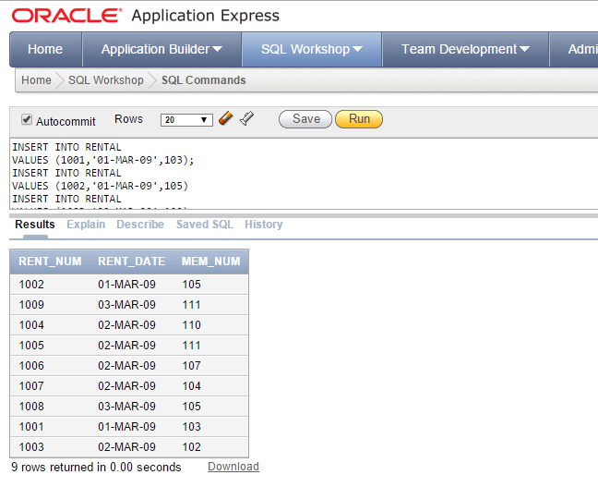

DETAILRENTAL:

INSERT INTO DETAILRENTAL
VALUES (1001,34342,2,'04-MAR-09','02-MAR-09',1);
INSERT INTO DETAILRENTAL
VALUES (1001,61353,2,'04-MAR-09','03-MAR-09',1);
INSERT INTO DETAILRENTAL
VALUES (1002,59237,3.5,'04-MAR-09','04-MAR-09',3);
INSERT INTO DETAILRENTAL
VALUES (1003,54325,3.5,'04-MAR-09','09-MAR-09',3);
INSERT INTO DETAILRENTAL
VALUES (1003,61369,2,'06-MAR-09','09-MAR-09',1);
INSERT INTO DETAILRENTAL
VALUES (1003,61388,0,'06-MAR-09','09-MAR-09',1);
INSERT INTO DETAILRENTAL
VALUES (1004,44392,3.5,'05-MAR-09','07-MAR-09',3);
INSERT INTO DETAILRENTAL
VALUES (1004,34367,3.5,'05-MAR-09','07-MAR-09',3);
INSERT INTO DETAILRENTAL
VALUES (1004,34341,2,'07-MAR-09','07-MAR-09',1);
INSERT INTO DETAILRENTAL
VALUES (1005,34342,2,'07-MAR-09','05-MAR-09',1);
INSERT INTO DETAILRENTAL
VALUES (1005,44397,3.5,'05-MAR-09','05-MAR-09',3);
INSERT INTO DETAILRENTAL
VALUES (1006,34366,3.5,'05-MAR-09','04-MAR-09',3);
INSERT INTO DETAILRENTAL
VALUES (1006,61367,2,'07-MAR-09',NULL,1);
INSERT INTO DETAILRENTAL
VALUES (1007,34368,3.5,'05-MAR-09',NULL,3);
INSERT INTO DETAILRENTAL
VALUES (1008,34369,3.5,'05-MAR-09','05-MAR-09',3);
INSERT INTO DETAILRENTAL
VALUES (1009,54324,3.5,'05-MAR-09',NULL,3);
INSERT INTO DETAILRENTAL
VALUES (1001,34366,3.5,'04-MAR-09','02-MAR-09',3);
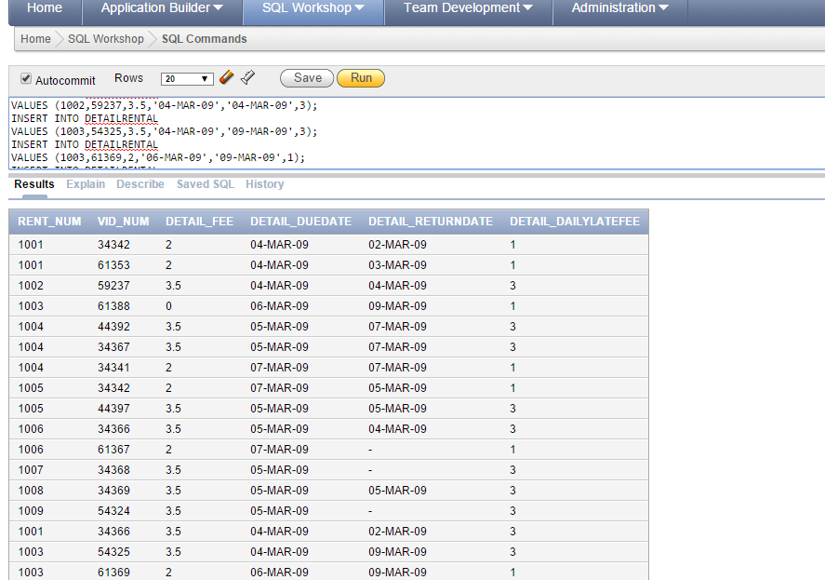

2.C Write the SQL command to save the rows inserted in Problem 2.B. (1 pts)

Solution:

COMMIT;

- How will you make sure that the value used in MEMBERSHIP.STATE is only TN, KY or TX? Show the syntax to add this check to the table and execute the statement. What happens when you try to insert a new row where the state is FL? Display the error message. (3 pts)

Solution:

Alter table Membership modify Mem_State check(MEM_State IN ('TN','KY','TX'))

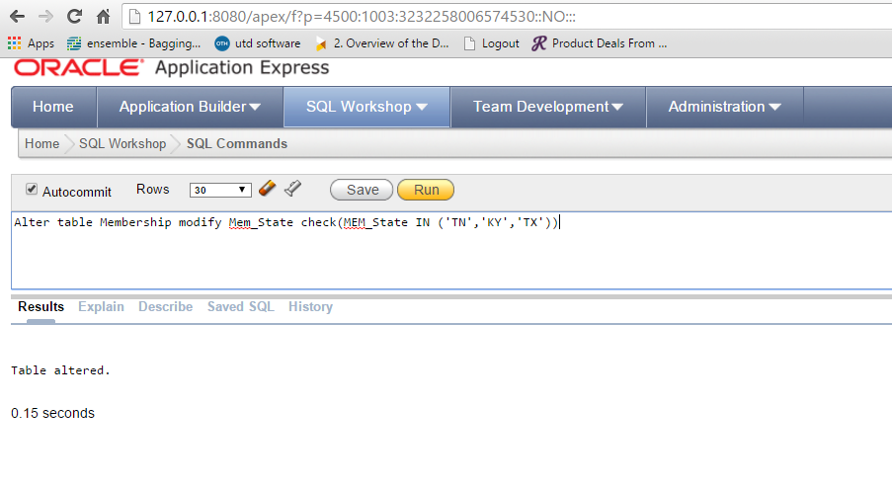
Insert into Membership values(114,'LOWES','TRACY','7756 MCCALLUM BLVD','ORLANDO','FL','23222',0)

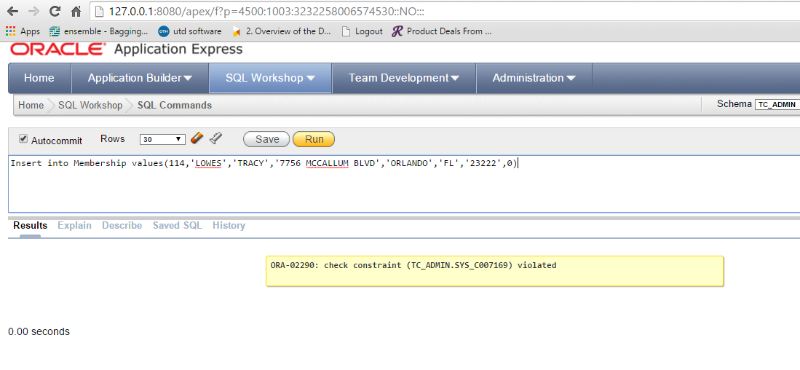

- Write a single SQL command to increase all price rental fee values by $0.50. (2 pts)

Solution:

Update Price set Price_RentFee =Price_RentFee + 0.50

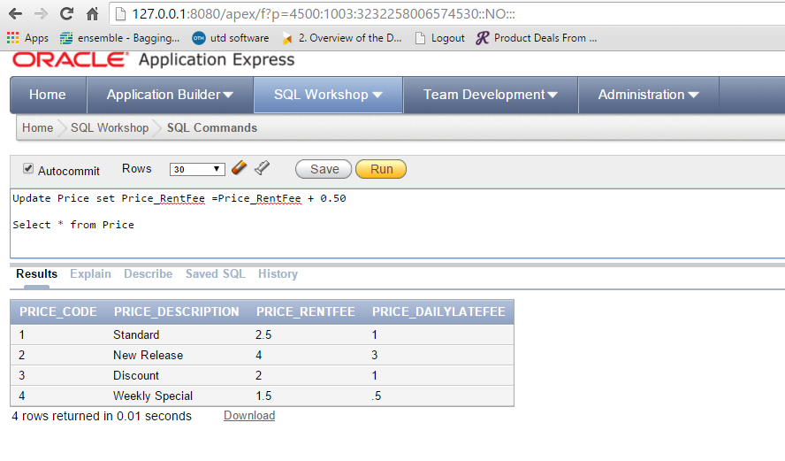

- Write a query to display the movie title, movie year, and movie cost for all movies that contain the word “hope” anywhere in the title. Sort the results in ascending order by title (result shown in Figure 5). (2 pts)
Figure 5 Movies with “Hope” in the title
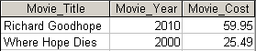

Solution:

Select Movie_Title, Movie_Year, Movie_Cost from Movie where Movie_Title like '%hope%' or Movie_Title like '%Hope%' order by Movie_Title

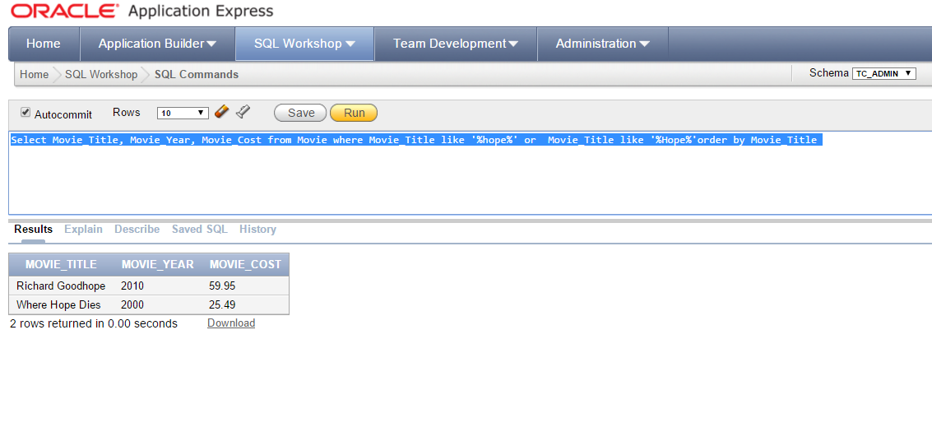

- Write a query to display the movie number, movie title, movie cost, and movie genre for all movies that are either action or comedy movies and that have a cost that is less than $50. Sort the results in ascending order by genre. (sample result shown in Figure 6) (3pts)
Figure 6 Action or comedy movies costing less than $50
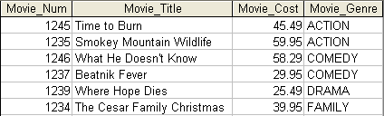l

Solution:
Select Movie_Num,Movie_Title,Movie_Cost,Movie_Genre from Movie where Movie_Genre in('ACTION','COMEDY') and Movie_Cost < 50 order by Movie_Genre

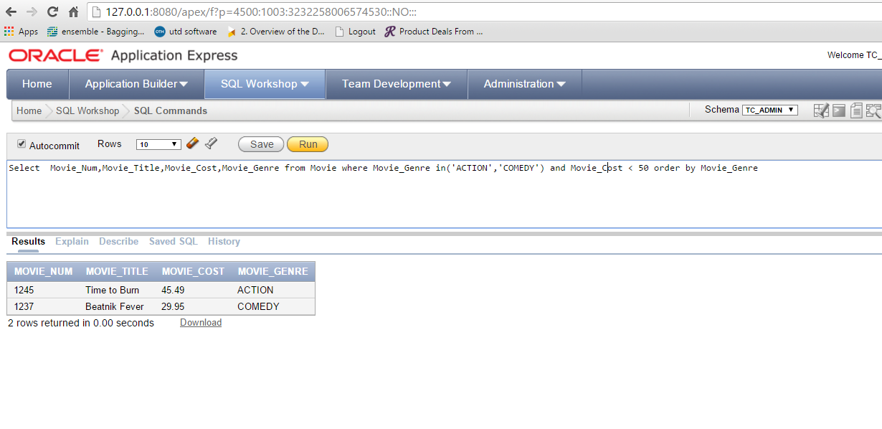

- Write a query to display the movie genre and the number of movies in each genre (sample result shown in Figure 7). (3 pts)
Figure 7 Number of movies in genre
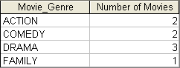

Solution:

Select distinct Movie_Genre, Count(Movie_Title) AS "Number of Movies" from Movie group by Movie_Genre order by Movie_Genre

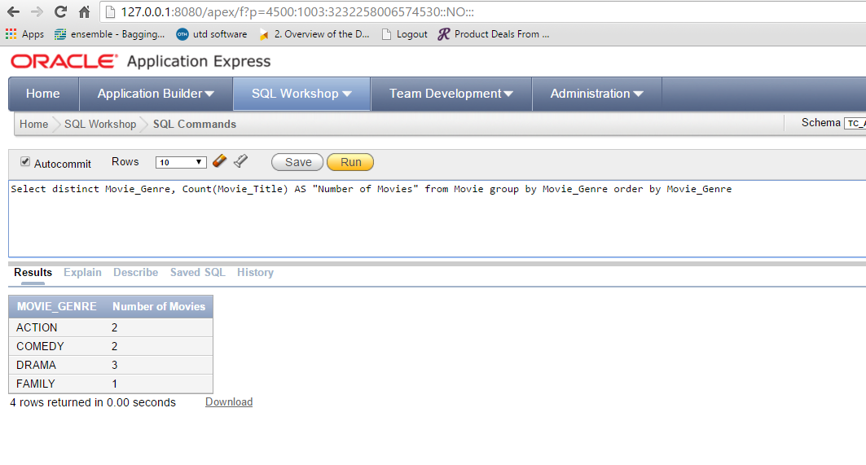

- Write a query to display the average cost of all of the movies – the field should be titled “Average Movie Cost” (sample result shown in Figure 8). (2 pts)
Figure 8 Average movie cost
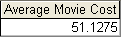

Solution:

Select Sum(Movie_Cost)/Count(Movie_Cost) AS "Average Movie Cost" from Movie

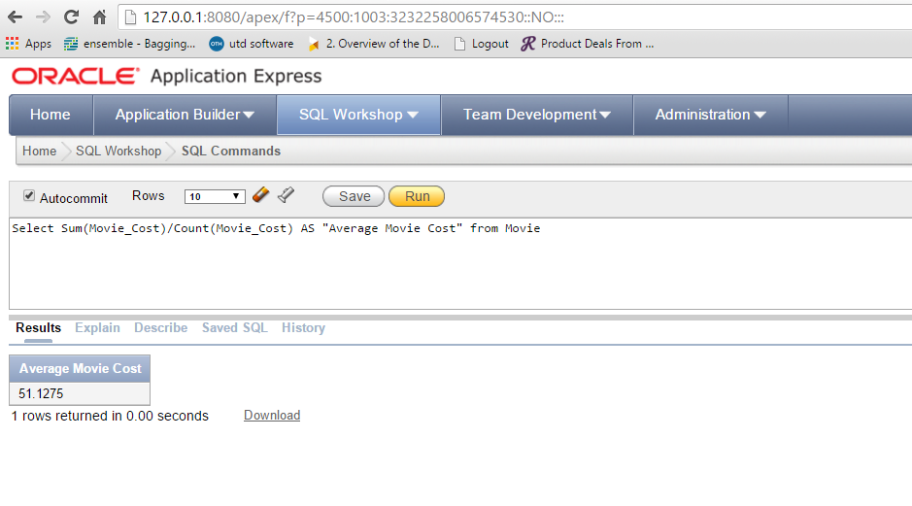

- Write a query to display the movie title, movie year, and the movie cost divided by the price rental fee “Breakeven Rentals” for each movie that has a price to determine the number of rentals it will take to break even on the purchase of the movie (sample result shown in Figure 9). (3 pts)
Figure 9 Breakeven rentals
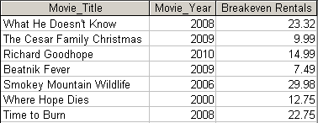

Solution:

Select Movie_Title,Movie_Year,Round((Movie_Cost/Price_RentFee),2) as "Breakeven Rentals" from Movie m inner join Price p on m.Price_Code = p.Price_Code

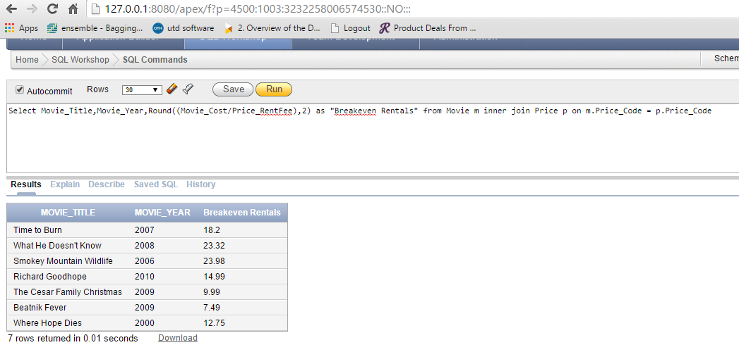

- Write a query to display the movie title, movie year, and movie cost for all movies that have a cost between $44.99 and $49.99 (result shown in Figure 10). (2 pts)
Figure 10 Movies costs within a range
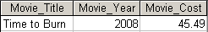

Solution:

Select Movie_Title,Movie_Year,Movie_Cost from Movie where Movie_Cost > 44.99 and Movie_Cost < 49.99

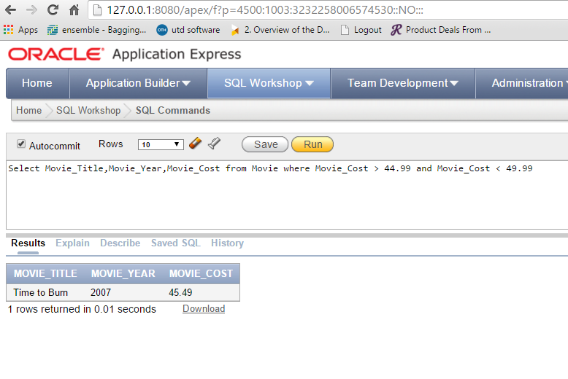

- Write a query to display the movie title, movie year, price description, price rental fee for all movies that are in the genres Family, Comedy, or Drama (sample result shown in Figure 11). (3 pts)
Figure 11 Movies with specific genres
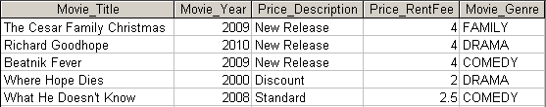

Solution:

Select Movie_Title , Movie_Year, Price_Description,Price_RentFee,Movie_Genre from Movie m,Price p where m.Movie_Genre in ('DRAMA','COMEDY','FAMILY') and m.Price_Code = p.Price_Code

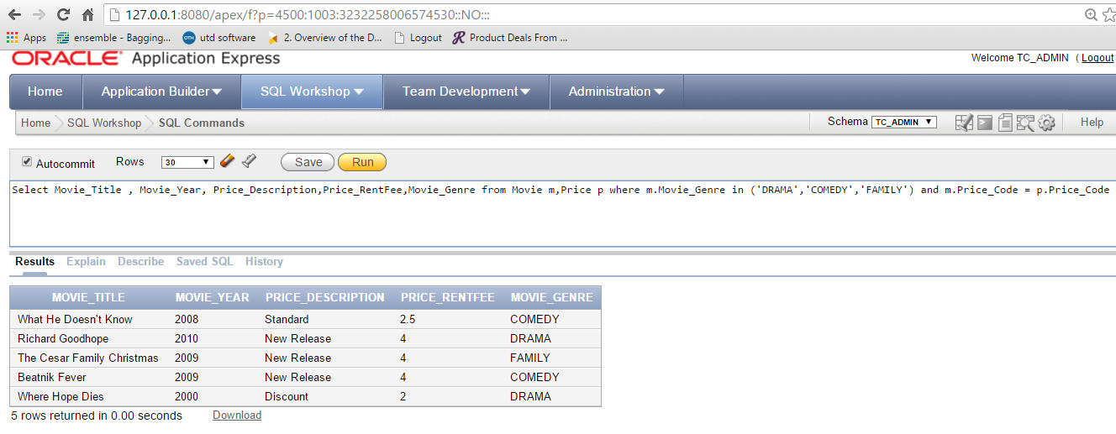

- Write a query to display the movie number, movie title, and movie year for all movies that do not have a video (sample result shown in Figure 12). (3 pts)
Figure 12 Movies without videos
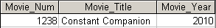

Solution:

Select Movie_Num,Movie_Title,Movie_Year from Movie where Movie_Num not in (Select Movie_Num from Video)

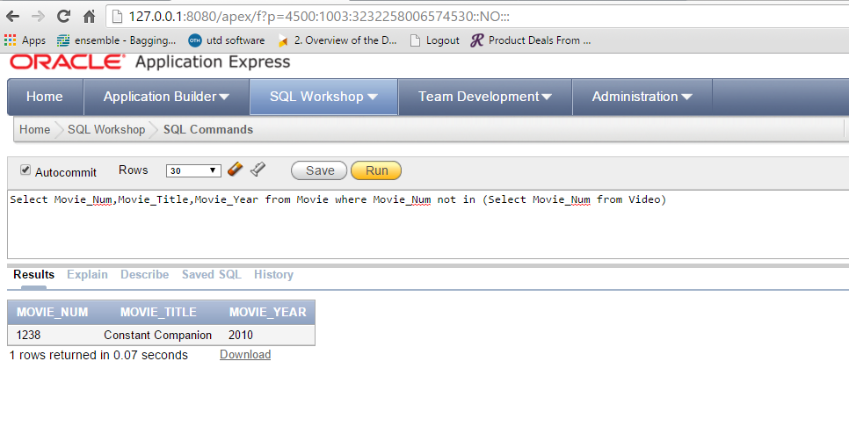

- Write a query to display the membership name (concatenate the first name and last name with a space between them into a single column), membership address (concatenate the street, city, state, and zip codes into a single column with spaces (sample result shown in Figure 13). (3 pts)
Figure 13 Concatenated membership data
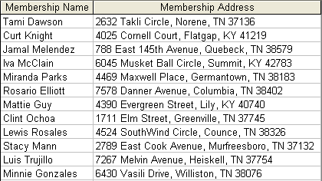

Solution:

Select Mem_FName || ' ' || Mem_LName AS "Membership Name" , Mem_Street || ' ' || Mem_City || ' ' || Mem_State || ' ' || Mem_Zip AS "Membership Address" from Membership

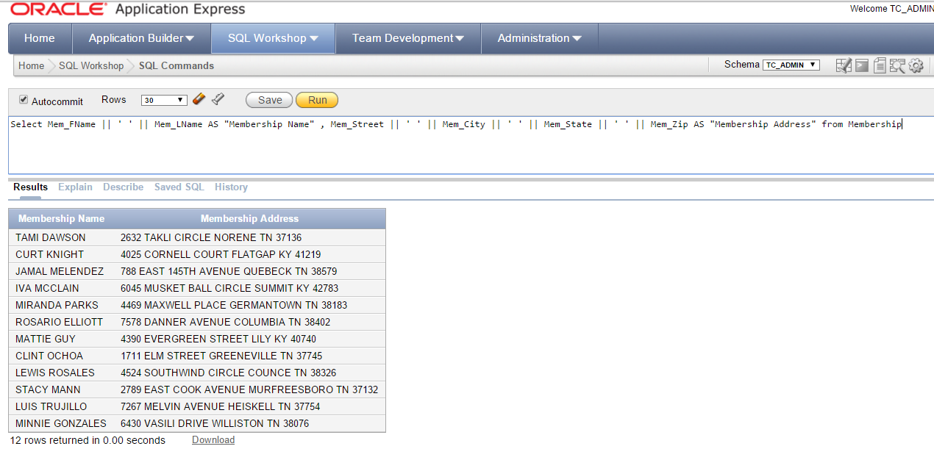

- Write a query to display the rental number, rental date, video number, movie title, due date, return date, detail fee, and number of days past the due date that the video was returned for each video that was returned after the due date. Sort the results by rental number and movie title. (sample result shown in Figure 14.) (3 pts)
Figure 14 Number of days late
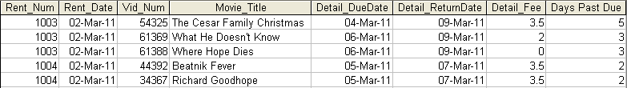

Solution:

Select r.Rent_Num, r.Rent_Date, dr.Vid_Num, Movie_Title, Detail_DueDate, Detail_ReturnDate, Detail_Fee,to_number(to_date(dr.Detail_ReturnDate,'DD-Mon-YY')-to_date(dr.Detail_DueDate,'DD-Mon-YY')) as "Days Past Due" from Rental r inner join DetailRental dr on r.Rent_Num = dr.Rent_Num inner join video v on v.Vid_Num = dr.Vid_Num inner join movie m on m.Movie_Num = v.Movie_Num GROUP BY r.Rent_Num,r.Rent_Date,dr.Vid_Num,Movie_Title,Detail_DueDate,Detail_ReturnDate,Detail_Fee having to_number(to_date(dr.Detail_ReturnDate,'DD-Mon-YY')-to_date(dr.Detail_DueDate,'DD-Mon-YY')) > 0 order by r.Rent_Num,m.Movie_Title
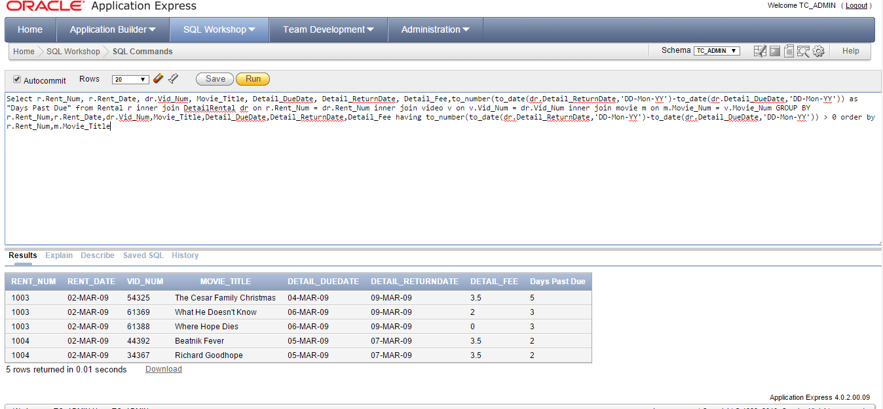

- Write a query to display the membership number, last name, and total rental fees earned from that membership (result shown in Figure 15). The total rental fee is the sum of all of the detail fees (without the late fees) from all movies that the membership has rented. (4 pts)

Figure 15 Total rental fees paid by membership
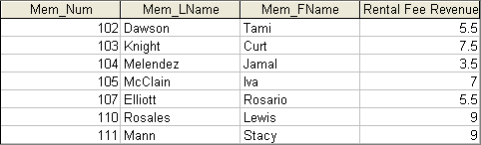

Solution:

Select m.Mem_Num,Mem_LName,Mem_FName,SUM(dr.Detail_Fee) as "Rental Fee Revenue" from Membership m inner join rental r on m.Mem_Num = r.Mem_Num inner join DetailRental dr on dr.Rent_Num = r.Rent_Num group by m.Mem_Num,m.Mem_LName,m.Mem_FName order by m.Mem_Num

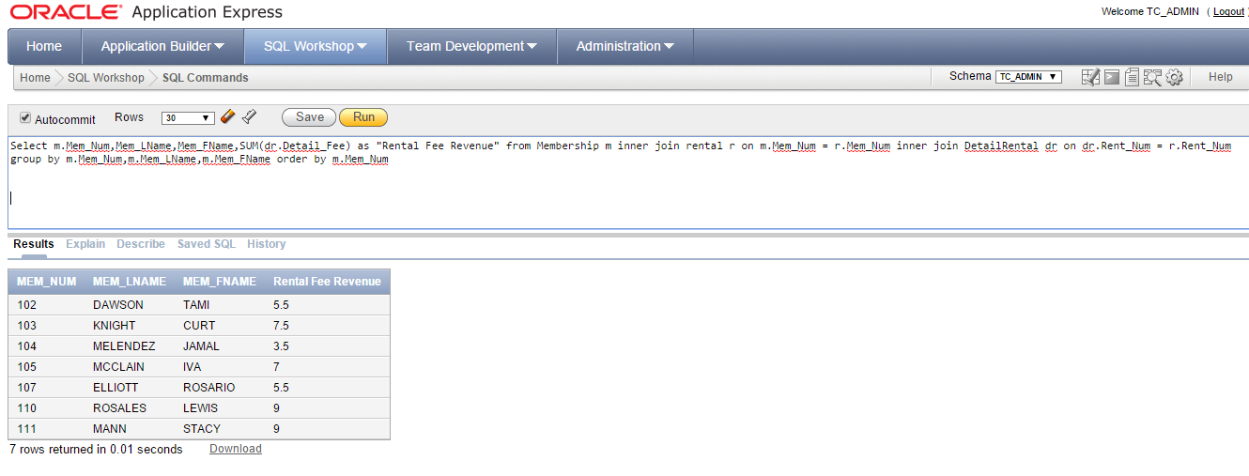

Extra Credit:
Write a query to display the movie number, movie genre, average movie cost of movies in that genre, movie cost of that individual movie, and the percentage difference between the average movie cost and the individual movie cost (result shown in Figure EC). Note: the percentage difference is calculated as the cost of the individual movie minus the average cost of movies in that genre, divided by the average cost of movies in that genre multiplied by 100. For example, if the average cost of movies in the “Family” genre is $25, if a given Family movie cost $26, then the calculation would be ((26 – 25) / 25 * 100), which would work out to be 4.00%. This indicates that this movie costs 4% more than the average Family movie. (5 pts)
Figure EC Movie difference from genre average
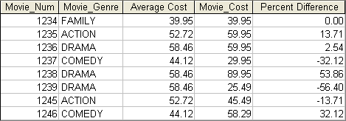

Solution:

Create View AverageCost_Movie as
Select Movie_Genre,AVG(Movie_Cost) as "Average Cost" from Movie group by Movie_Genre

Select distinct Movie_Num,av.Movie_Genre,Round("Average Cost",2) as "Average Cost",Movie_Cost,Round(((Movie_Cost - "Average Cost")/"Average Cost") * 100,2) as "Percent Difference" from Movie m inner join AverageCost_Movie av on m.Movie_Genre = av.Movie_Genre
